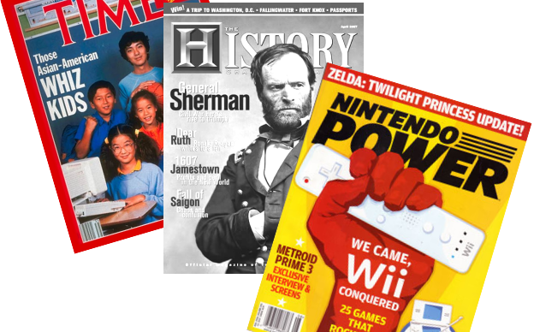




Your Task: Read about the Dynasty & section you chose, then represent the information as the cover of a magazine. This final result should look clean and artistic like a magazine cover (colorful block letters, quality artwork, etc.) but first you must create a non-colored rough draft. The page can be laid out however you choose but must include ALL of the following:

- The title of the dynasty/section.

- A few key terms/dates from the dynasty along with a short definition.

- The main people involved in this section and what they did.

- Two statements/sentences copied directly from the textbook that you found interesting about your dynasty.

- Two questions you make up that are answered in this section.

- At least 2 graphics (drawings, maps, graphs, symbols, cartoons, Venn diagrams, graphic organizers, etc.) These should tie in with the sentences you chose in number four.

- A personal response/opinion - a comment, a connection, or an interpretation. (This reminds me of… I feel that… This makes me think…)

- Your name in the lower right corner.

9. Create a final draft of your magazine cover using ink and color. It must look like a magazine cover not just like a list of answers! You must have both a rough and final draft.

