Submitting Assignments
- After reading the assignment directions and you are ready to submit your work, click “Submit Assignment” in the upper right hand side of your screen.
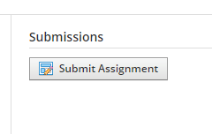
Now you have a few options. If you typed your assignment and saved it as a file (Microsoft word, power point, picture), upload your file by clicking the word UPLOAD. Next, click the file icon. Find your file that is saved on your device and attach it. Finally, click submit.

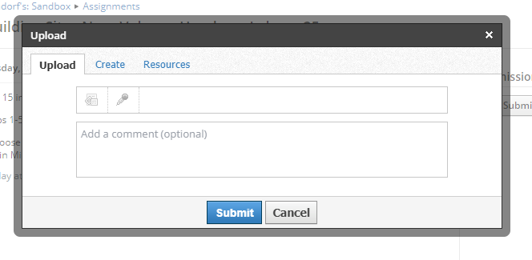

- If you want to type your answers directly on this page then click CREATE. After typing your answers, click submit. You can also add attachments to this page if you wish. Then you should be all set!
